AI Assisted Coding (III Year) Assignment
Name: B. Rithwik
HT NO: 2303A52330
Batch: 35
Lab 13 – Code Refactoring Using AI (Python)
Lab Objectives
- Use AI to assist in designing and implementing fundamental data structures in Python
- Learn prompt-based structure creation, optimization, and documentation
- Improve understanding of Lists, Stacks, Queues, Linked Lists, Graphs, and Hash Tables
- Enhance readability and performance with AI-generated suggestions

Task 1: Removing Code Duplication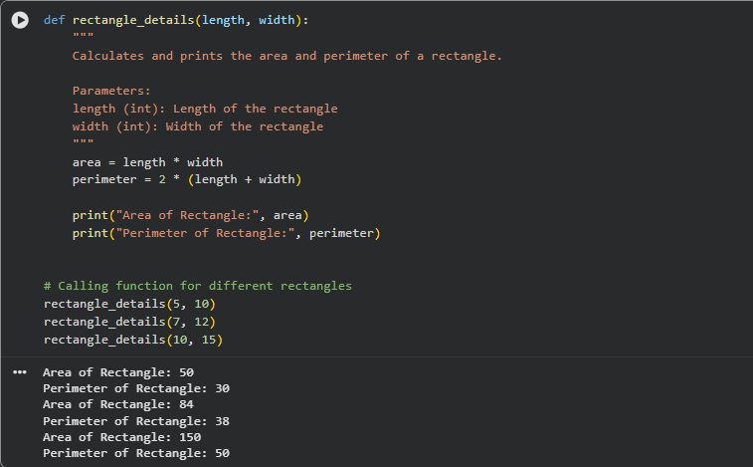

Explanation
The repeated calculations were moved into a reusable function, reducing duplication and improving readability.

Task 2: Optimizing Loops and Conditionals
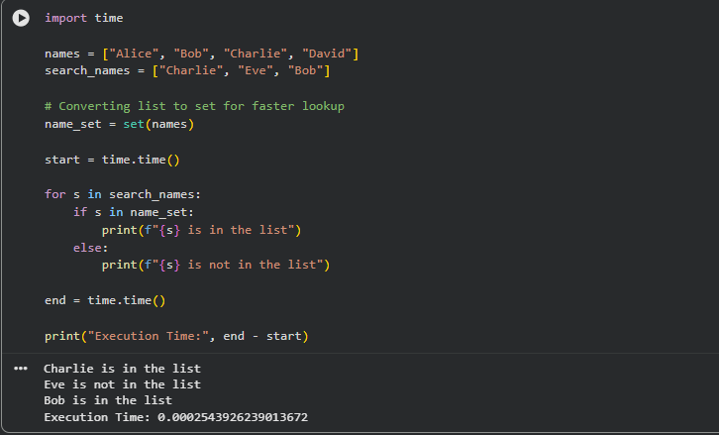
Performance Comparison
Method | Complexity | Description
Nested Loops | O(n²) | Each element compared repeatedly
Set Lookup | O(n) | Faster search using hash lookup
Set lookup is faster because sets use hashing.

Task 3: Extracting Reusable Functions

Recommended Algorithms
Operation | Algorithm | Justification
Search by Appointment ID | Hashing | Fast lookup
Sort by Time | Merge Sort | Stable and efficient
Sort by Fee | Merge or Quick Sort | Efficient for large data

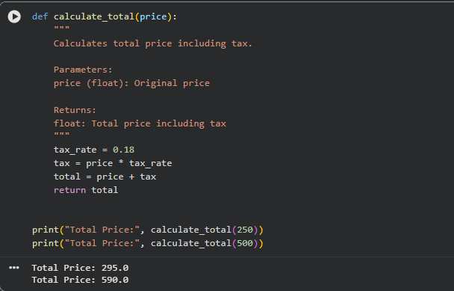
Improvement
The repeated tax calculation is now modular and reusable.
Suggest efficient searching and sorting algorithms for an appointment system and implement Python functions with justification.

Task 4: Replacing Hardcoded Values with Constants.

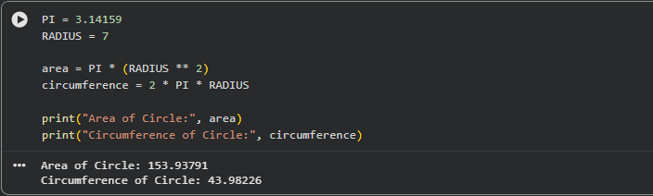
Improvement
Hardcoded values were replaced with named constants, improving maintainability.

Task 5: Improving Variable Naming
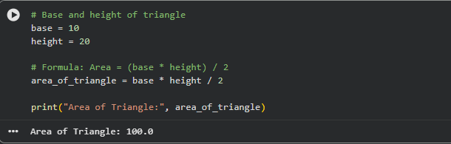

Improvement
Variables now clearly explain their purpose.

Task 6: Removing Redundant Conditional Logic

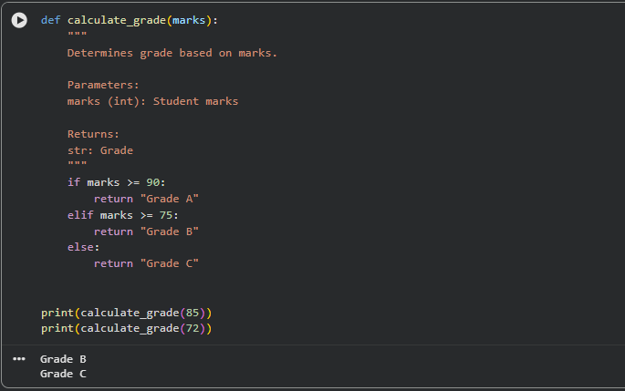
Improvement
Grading logic is now reusable and centralized.

Task 7: Converting Procedural Code to Functions

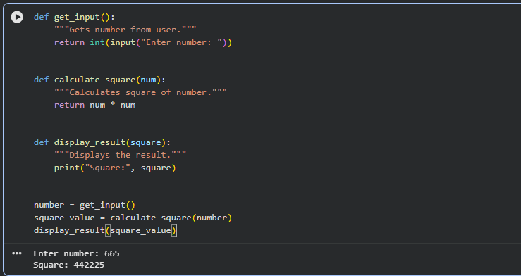
Improvement

Task 8: Optimizing List Processing

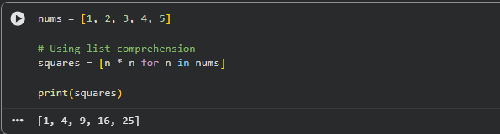

Improvement
List comprehension makes the code shorter, faster, and more readable.
Final Conclusion
Code refactoring improves readability, maintainability, and performance of legacy code. Using AI-assisted tools helps developers quickly identify code smells such as duplication, inefficient loops, hardcoded values, and poor naming conventions, and transform them into modular and optimized implementations following modern Python best practices.

